**Building Blocks for Smart Impact Bonds in Developing Regions: Crowd-Validation, Consensus-Metrics, and Scaling Impact**

Dr. Tat Lam

Chief Social Scientist, iO2 Foundation

In my previous 10 years experience researching and engaging with grassroots communities, I cautiously discover an increasing development divide every times when new technologies try to bring ‘new solutions’ to close the divide. It is no longer about those that have or have not, but between those that can or cannot. Technocracy, solutionism and microscopic methodologies oversimplify complexity from the field and isolate technological development from reality. Blockchain technologies have been previously widely advocated in the same way, i.e. the over-promising for its grand vision to decentralize concentrations of value as a means to democratize and distribute power, but severely under-delivering for its impact for real people, with real problems, in the real world. In the following writing, I wish to depart from the narrowed view of smart impact bond computational and legal technicalities, but to reveal a holistic approach on what chronological considerations, before and after the smart impact bond is created and implemented, especially when it is happening in vulnerable communities that do not have the digital or data literacy for their own advocacy.

**Case I - Family Structure Reinforcement in Rural China - Beneficiary *Need* for Insights Driving Data Validation**

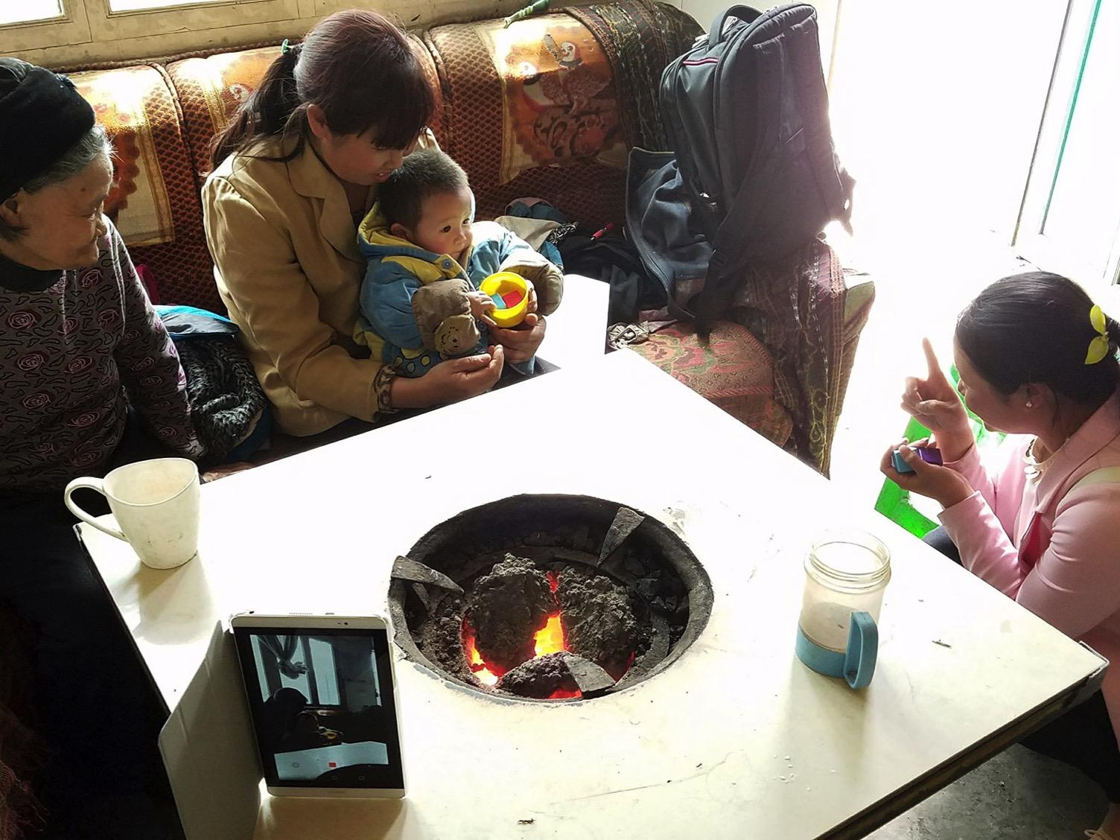

*In a village in the southern province of Guizhou, China, a “home visitor” employed by a central government foundation, squats down to the floor beside the family dining table and hearth, to conduct her weekly early childhood development (ECD) program with the caregiving family members, and hands the child a plastic cup filled with colored blocks. The home visitor was one of a handful of participants selected from the local area, who received basic ECD training by the foundation, and actively participate in the nationwide poverty alleviation program in China.*

*Across the table sits the 34-year-old grandmother, holding her grandchild in her lap, staring at the curated activity passively. The child’s great-grandmother was smiling from the corner of the table, while a mobile device was recording video from the other corner to collect data.*

*However, without the presence of the child’s parents, currently working as migrant labor in big cities thousands of miles away, the family is reluctant to participate or share information needed to validate the impact of this meaningful but arguably expensive social development program. The foundation’s concerns are that without quality data, the program will have difficulty validating the impacts to justify the costs, and to scale quickly.*

*After packing up all materials for the home-visit session, the home visitor did not leave the family, but instead, voluntarily spent another 30 minutes with the grandmother, helping her to manage all the activities requiring rudimentary digital and data literacy, including sending images of the “left-behind child” to his mother. Inside the home visitor’s smart device, she saved all valuable data about the family, more than enough to validate impact of the program, and further, has more than 20 families like that.*

**Data Literacy as Building Block for Social Finance**

The above is our first-hand observation from extensive fieldwork on the frontlines. We define the role of the home visitor as a ‘data intermediary’, who helps to close the data divide pervading developing regions, which further exacerbates social inequalities moving into the data-driven future. The Early Childhood Development (ECD) program is implemented by China Development Research Foundation (CDRF), a policy think tank for the central government, which conducts Random Control Trials (RCT) for social development programs that fight poverty. To CDRF, impact measurement is key to triggering decisions towards capital deployment in an effort to scale the program to other provinces as a public-private partnerships across China. However, the cost of impact measurement is high, not due to the analytic models, but the gathering of quality data from the frontline.

In addition to the data solutions we are providing CDRF with field kits for data collecting, dashboards for M&E, and data science for analytics, the key agenda was to focus on building data literacy in the community, as a means to fundamentally solve problems of program participation, efficiency, and quality of data collection and generation. In the following diagram, we measure data literacy and impact data readiness with multiple dimensions to help us understand how ready a community or program engagement is able to utilize digital tools and data to create bilateral data flows, that benefit the communities as well as the organizations like CDRF.

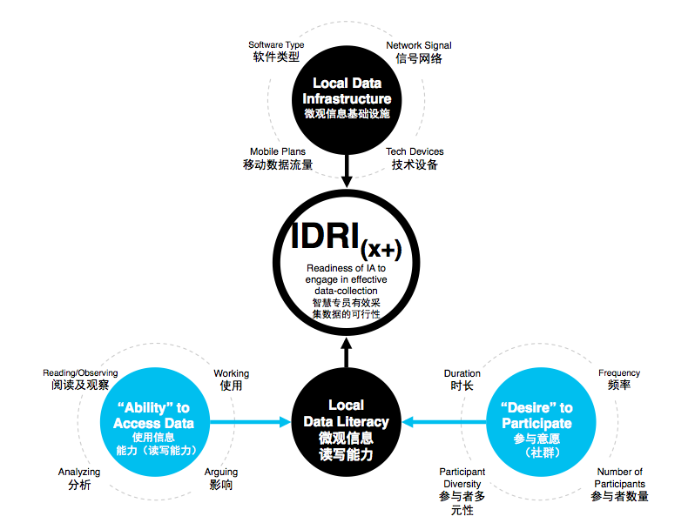

For us, this fundamental indexing of Data Readiness is requisite to making data-driven solutions like AI and blockchain meaningful to these communities, without which data-dependent projects risk abject failure by misreading the nature of frontline engagement. In this process, we automate the measurement of access to data infrastructure, the ability of communities to access and gain value from data, and their desire to participate in such systems. This creates what we call the IDRI or Impact Data Readiness Index.

**Bilateral Data Flow as the basis for Proof of Impact**

To endeavor bringing end-beneficiaries *online*, or even *onchain*, the key is how to let them co-create and gain value from social development programs, thereby compelling them to participate and contribute data towards the measurement process. For CDRF, we developed mobile device-enabled fieldkits to foster bilateral information flow between the end-beneficiaries and the cloud, making the process of data collection meaningful to beneficiaries because in return, they also receive insights that are useful to them in their daily lives and helps with long-term planning or behavior changes.

Data is collected in a few ways along the value chain such as operational data, frontline engagement data, self-reported data, and ambient data – sometimes with in-person assistance of data intermediaries, sometimes self-guided interactions with the cloud, both of which generates behavioral metadata to reveal hidden patterns of holistic impacts. More importantly, the more beneficiaries engage with bilateral data exchanges, the more value they gain from providing more accurate data, and embody custodianship to validate the data integrity, and the more they engage with the cloud, the more awareness is gained revealing how data can manipulate or empower invisible automated systems that govern or affect local outcomes, growing community abilities to form data-*based* argumentations.

We are researching and developing systems for how this process, powered by crowd-validation, can become the basis for Proof of Impact – data supplied by the oracle onto the blockchain required to trigger Smart Impact Bond actions, where in the case of last-mile data validation, the network of end beneficiary data behaviours powers the oracle. Not only can this disintermediate third party auditors that have little to no expertise in measuring the specific context of social development, but can also provide the opportunity to organically grow inclusive crypto-economics that incentivize beneficiaries and their communities to increase involvement in impact validation, either actively or passively.

**Case II - Automating Local Crowd-Sourced Community Action in Myanmar**

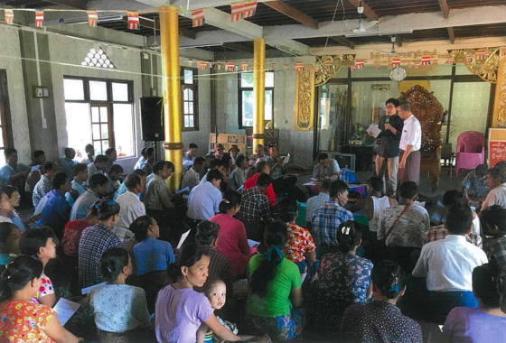

*In Yangon Myanmar, there is a community of 70 people gathering in a township hall meeting listening to a citizen voicing out his concerns with the frequent power outages within the urban ward. When he is suggesting the local government to build a power plant near the township, there are voices of support as well as disapprovals.*

*This is a township consultation session initiated by a government finance and civic engagement solution organization MM Community, allowing community members to propose and discuss about the impact of different infrastructure proposals. If the proposal is well received by the public, the regional ministry of electricity and energy would approve the project, and publish a funding campaign of MMK 200 million (around UDS 150k) with a 3% government bond. Here, the better-off community members would pledge MMK 100,000 each for a power supply project with a 2-year and 3% government bond. The community bond holders would be repaid by the Union Government when the power plant is well completed.*

*It took a day for citizens, township administrators and community fund contributors to reach a consensus about the government bond mandate, including the description of the project itself, costs of construction, as well as the condition of repayment.*

**Micro Social Impact Bond**

This strategy assists the Union Government to decentralize and thus increase its sources of funding and channels of civic engagement. At the same time, this solution provides a channel of voice, information and decision making to local citizens who can propose and finance community

infrastructure projects. Meanwhile, such model also incentivizes international donors to invest in impact infrastructure projects that are supported by local community members.

In our opinion, this community-driven government bond is essentially a pay-for-success (P4S) contract without a clear definition of milestones and impact metrics. This means that community fund contributors may eventually receive repayment, but the impact of the power supply is not validated by all township members affected by the project. As the majority of community members may not have the time or chance to participate in town hall meetings, they may not have the opportunity to express their concerns about the power supply. There is a possibility that citizens who live nearby the power supply would suffer from noise or pollution, yet without the mechanism of defining impact metrics and validating intended or unintended consequences, their voice would be unheard throughout.

**Consensus Metrics**

Building upon the existing mechanism of town hall meetings and decision making processes, we are working with MM Community to add a critical layer of Crowd Consensus Metrics to ensure that all positive and negative, intended and unintended impact of these community-driven infrastructure projects are captured. Our goal is not merely to professionalize the bond creation and execution process through impact measurement, but more importantly to amateurize the participation process through engaging with more local community members with a diversity of identities, needs and interests.

The essence of Consensus Metrics is to co-create impact metrics and validation approach with stakeholders including community members, fund contributors, municipal agents

who are the most critical stakeholders of the infrastructure projects. Consensus Metrics is a method by which all stakeholders can join the poll for how projects should conduct their inner and outwardly governance, and how to capture and measure the impacts as such. In the scenario of town hall meetings in Yangon, the citizen who first propose the power plant project can suggest metrics that he thinks are relevant to solving the social problems in the township. Then, municipality agents can involve other stakeholders including donors and community fund contributors to mandate metrics in addition to or to supplant metrics identified by the author of the project. Following is a dialogue that may better inform the creation, negotiation, and finalization of the pay-for-success contract.

Such process of automating consensus metrics is a prerequisite to implementing PoI for an actual P4S smart contract. In order to involve a diversity of community members who are usually excluded from public discussions and consultations, for instance ethnic minorities and women, it is important to ensure that all community members have the equal access to data channels and voting platforms. This means deploying consensus metrics not only inside the town hall meetings, but also on everyone’s phone via people-centered DApps.

We are developing mechanisms that help calculate the costs of oracles for deploying consensus metrics with different stakeholders. Such calculation would consider diverse oracle types, stakeholders engagement approaches, as well as the number of stakeholders involved. This number is essentially the cost of bringing crowd intelligence online in order to activate P4S smart contracts.

**Case III - Inclusive Crypto-Economics to Scale Last-Mile Engagement in Brazil**

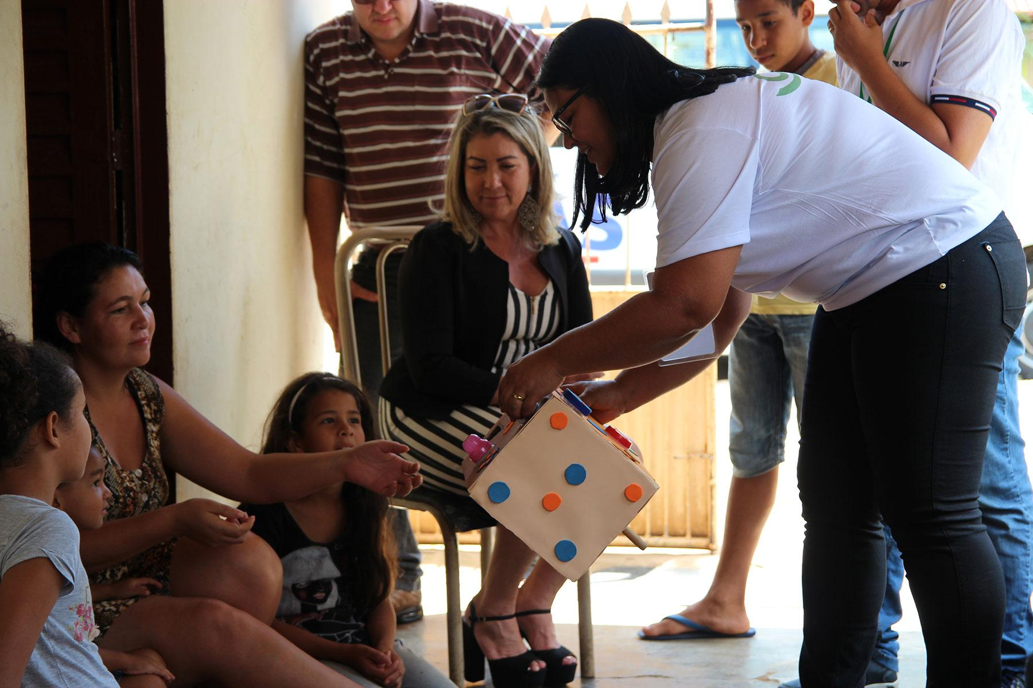

*The Brazilian government is implementing a nation-wide early child development (ECD) program Happy Child (Programa Criança Feliz), targeting children between 0 and 3 years old living in deprived and low-income families which already participate in income transfer programs such as Bolsa Familia and the Continuous Cash Benefit (BPC). Happy Child Program aims conduct weekly home visits to vulnerable children and their families in order to identify risks and opportunities for child development. The vision of the program is to eventually eliminate neonatal mortality and in longer term education inequality.*

*Weekly visitors maintain trusting relationships with beneficiary family members from being a part of their local fabric, identifying their root social needs. However beneficiaries usually do not understand how the data collected by the visitors is used. One visitor explained to us, “when we ask mothers about their social and family needs, they tend to be nervous and avoiding answering the questions directly. I think they are afraid that the data collected will disqualify them from participating in the National Conditional Cash Transfer Program Bolsa Familia or getting flagged for informal activities.”*

*Frontline data collection can often degrade trust between data agents and beneficiary family members, lowering program participation and preventing rapid scaling of the program. This is essentially a problem of data ownership and data sovereignty that can be potentially solved by blockchain.*

**Identity & Data Sovereignty as the Start of Inclusion into a Blockchain Future**

Indeed the most compelling implications of blockchain until now is a force to transform the modern finance industry, and like a mirror to the modern finance industry, it is designed only to serve a very small percentage of the world, leaving a majority of the world in the dark, despite the ambitions of its founding authors. However, just as in the finance industry, there was born a gleam of inclusivity loosely known as Social Finance or Impact Investment, which until now, was lacking in ability to scale beyond institutional activity. Blockchain can change this, and it begins with economic identities for everyone.

In Brazil, we are working with the Ministry of Social Development to assist their national Early Childhood Development (ECD) program with data services to aid the delivery of neonatal ECD services to children faster and more responsively, as well as to help scale to their 70 million beneficiaries nationwide. We begin by developing Decentralized IDs for pilot community projects in order to test how last-mile crypto-economics can feed data into DApps that not only tell project managers monitoring and evaluation metrics, but contain the means for automating the extraction of necessary data points to execute smart impact bonds.

One major barrier to automating this dataflow is the onboarding of fringe-communities onto such programs to bring them “online” or on the grid, ultimately to share their personal data. For vulnerable communities such as indigenous or impoverished communities in Brazil, ethnic minorities or migrants in China, or refugees in Myanmar, they may have many socio-political reasons to remain undetected, and by default exclude themselves from participating in social development programs. There is simply a lack of trust that the sharing of their data will not be used adversely against them. To safeguard this, we are adopting the ID4D protocols into our DID development, as prescribed by the World Bank, as means to empower vulnerable communities to take control of their identity and data they produce and own.

This is more important to grassroots communities, especially for those without a political identity to be treated fairly for who they are, what they do, what they know, and what they possess. In developing regions, money is a scarcity but personal assets like property, knowledge, or data is in high demand, but may not have a mechanism to become value-producing.

Once on the blockchain, even the most vulnerable can protect their data, identity, and therefore personal safety, while still being able to participate in social development programs that they can trust will not spill their information to bad actors, and can even begin participating in larger scale crypto-economics starting at the last-mile.

**Scaling Impact to the Shadow Economy - Scaling the Shadow Economy with Impact**

Crowd-validation in the first case in China, and crowd-metrics in the second case in Myanmar are two fundamental engines to drive automation of social capital deployment on the blockchain, no matter how massive the community, or how small the financial vehicle. Once the smart impact bond is generated collectively and the first milestone validated, the entire stakeholder community moves to focus on the second milestone with a new metrics consensus process, then validation, etcetera.

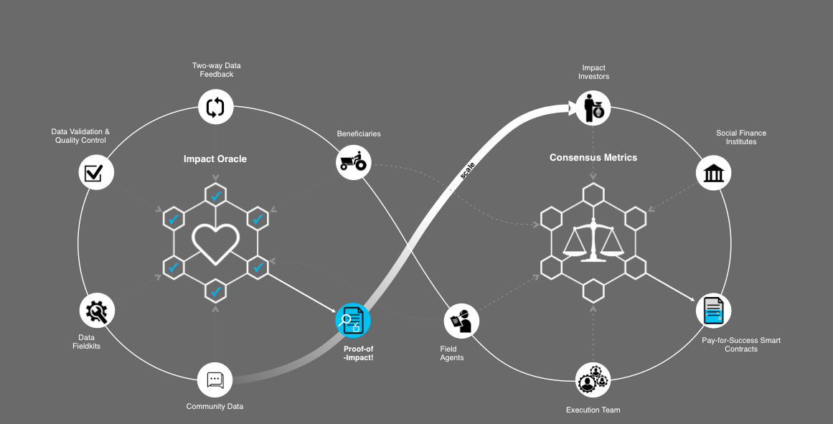

The scalability is based on mass participation, therefore the social finance infrastructure is turned upside down - grassroots make decisions to reshape the social finance infrastructure to the specificity of their everyday lives.

Last but not the least, the shadow economy refers to all informal economic transactions in the communities. It is the originally marginalized by modern society, for the sake of exploitation or exclusion, effective management or just ignorance. However, all kinds of data are in this network and the value is yet to be unlocked. iO2 Foundation aims to work closely with grassroots communities, starting with tokenization of impact data, but eventually developing the ecosystem of blockchain technologies on the ground, where the smart contract can be a perfect vehicle for reducing the risk of participating in the shadow economy, further allowing economically marginalized actors to take bigger risks without fear of systemic insecurity or instability.

We believe this will pave the way for Market for Poverty (M4P) partners to proliferate as important driving forces for sustainable development of the shadow economy, powered by iO2 tokens, where the role of iO2 not only builds a value-exchanging platform between social purpose organizations and end-beneficiaries’ last-mile data, but also developing a network of M4P partners for commodity incentives to participate and contribute to the collective value co-creation process of social development.